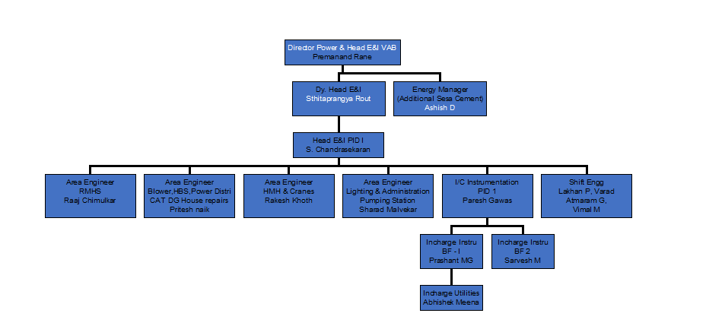

|  |  |  |
| --- | --- | --- |
| **Prepared By:**  Senior Elect. Engineer | **Reviewed & Issued By:**  Management Representative | **Approved By:**  Head – Electrical & Instrumentation PID I |
| **Signature** | **Signature:** | **Signature:** |
| **Review Date: 04.03.2023** | **Review Date: 04.03.2023** | **Review Date: 04.03.2023** |